Student ID: 10684079

**1. Entity relation diagram**

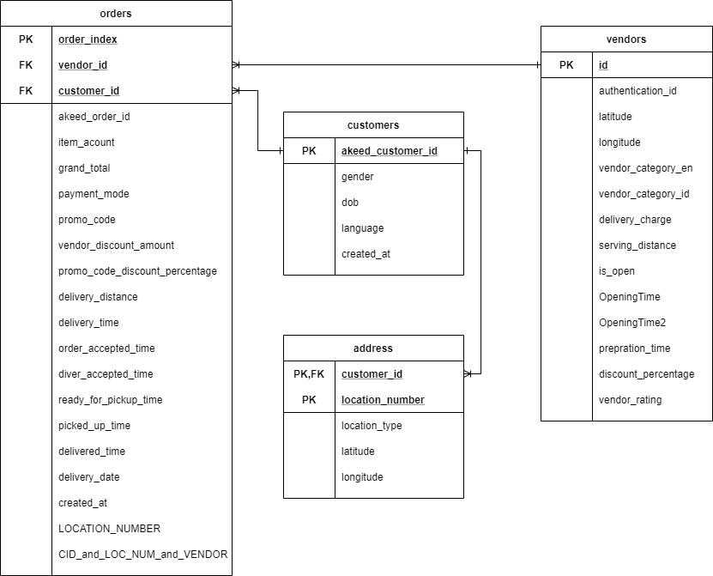

**Design choice**

This entity diagram includes 4 tables which are customers, address, orders and vendors separately. Table customers has one to many relationships with both orders table and address table since a customer can have more than one address and place more than one order. Table vendors has one to many relationships to orders table which means every vendor can take many orders.

In the customers table, column akeed_customer_id was chosen to be the primary key so I checked the duplicates of this column. At the same time, I found out that the column does have duplicates. For example, an id OFOCFVI appears 17 times. Therefore, all duplicates were deleted.

In address table, customer_id and location_number are composite primary key since one customer can have more than one address. However, location_number can help to identify the feature of each address such as work or home. Moreover, no duplicate was returned by checking both customer_id and location_number at the same time. Customer_id is also the foreign key referring to the primary key akked_customer_id in customers table.

In vendors table, id is the id for vendors as primary key since it is unique.

In orders table, order_index is the primary key. Customer_id and vendor_id are both foreign keys. At the beginning, akeed_order_id was chosen to be the primary key. However, I found it could not be primary key since it has Nan value in this column. For example, customer_id AIOLWXY has three orders which does not have akeed_order_id and has no pick_up_time and delivered_time neither. According to that, those orders might be failed orders. However, I think failed orders may also be useful for future query. Therefore, I did not delete rows with Nan values so I created an index for orders as order id. Foreign key customer_id is referring to primary key akeed_customer_id in customers table. The other foreign key vendor_id is referring to primary key id in vendors table.

1. **GUI interface**

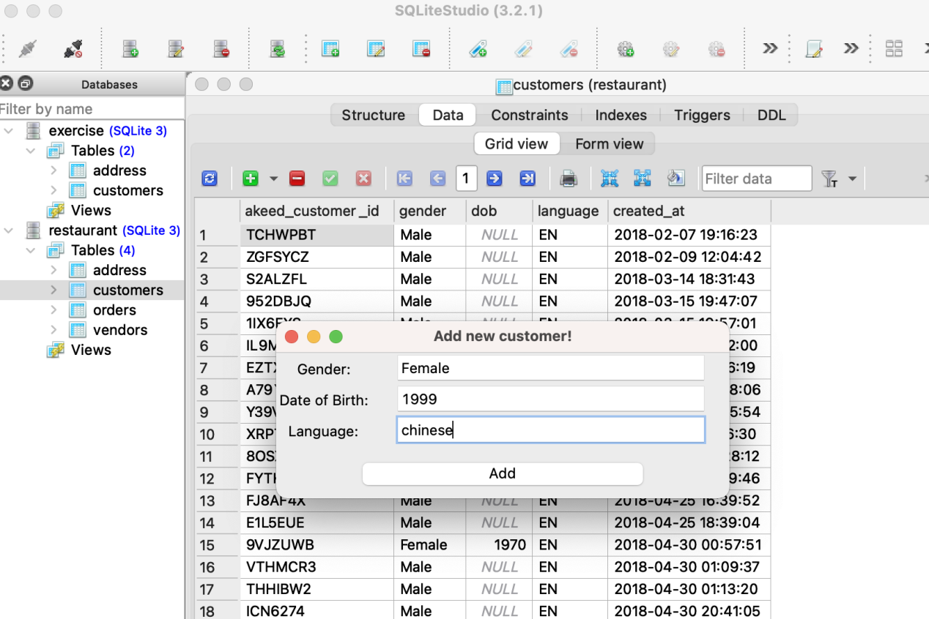

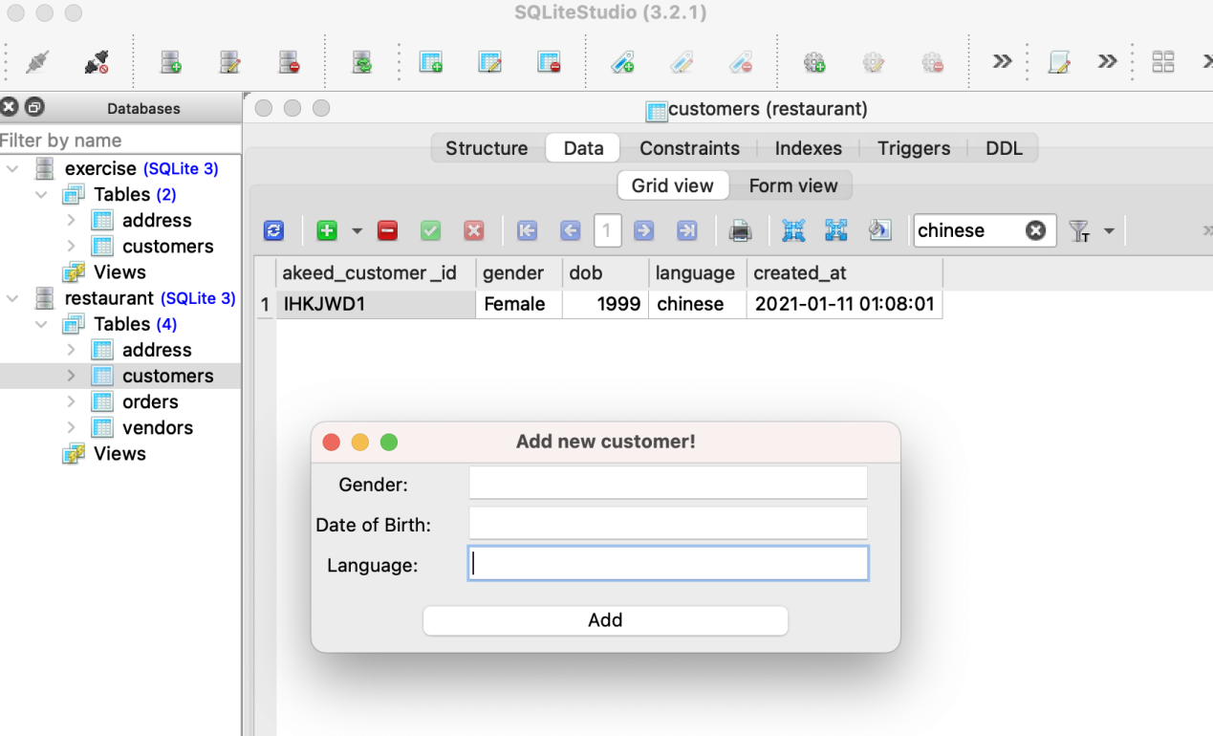

**3. GUI dashboard**

* **With Jupyter Notebook**

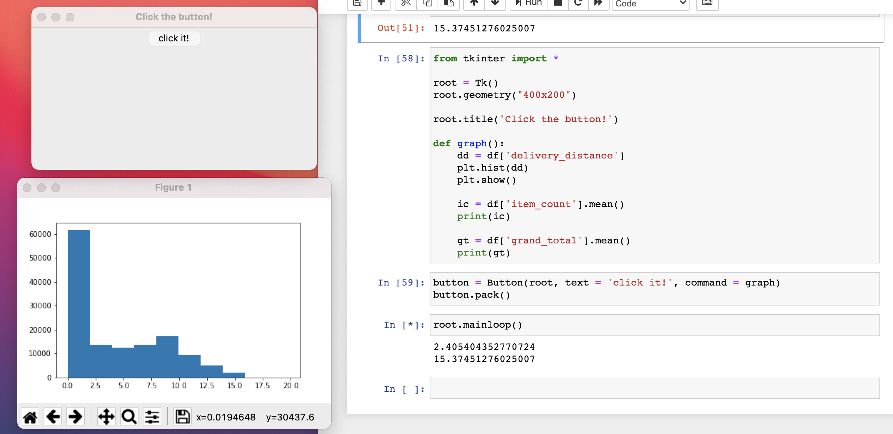

* **With Spyder**

